PATTERNS
KS1 – 2005 Paper 2
1.
66 and 88

KS1 – 2007 Paper 1
2.
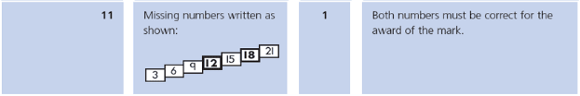
3.
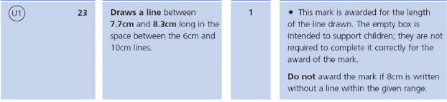
4.
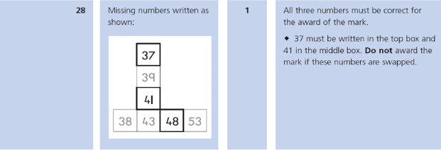
KS1 – 2016 Paper - Reasoning
5.
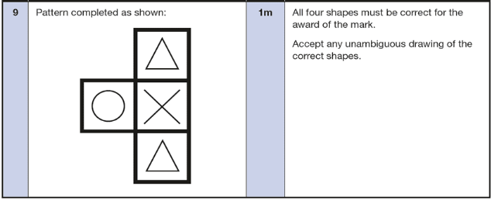
KS1 – 2018 Paper – Reasoning
6.
KS1 – 2019 Paper – Reasoning
7.
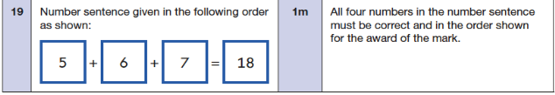
8.

